Requirements for this paper:
 | Multi choice cards: |  | Programmable calculator: |  |  |  |  |  | Open book examination
 | Graphic paper: |  | Laptop:
EKSAMEN/  EXAMINATION: |  |  |  | Semestertoets 1 Semester test 1 | kwalifikasieprogram/  /QUALIFICATION program:
modulekode/  Module CODE: |  |  |  | EERI 423 |  |  |  |  | duur/  duration: |  | 1.5 uur / 1.5 hours
module beskrywing/ module description: |  |  |  | Telekommunikasie / Telecommunication |  |  |  |  | maks / max:
EKSAMINATOR(E)/  examiner(s): |  |  |  | Prof A.S.J. Helberg |  |  |  |  | datum /  date: |  | 2017-03-28
 |  |  |  |  |  |  |  |  | tyd / time: |  | 09:00
moderator: |  |  |  | Prof J.E.W. Holm

Totaal / TOTAL: 75

Vraag 1 / Question 1 - [23]
  - Gee die frekwensiedomein voorstelling van die volgende sein:
Give the frequency domain representation of the following signal: [2]
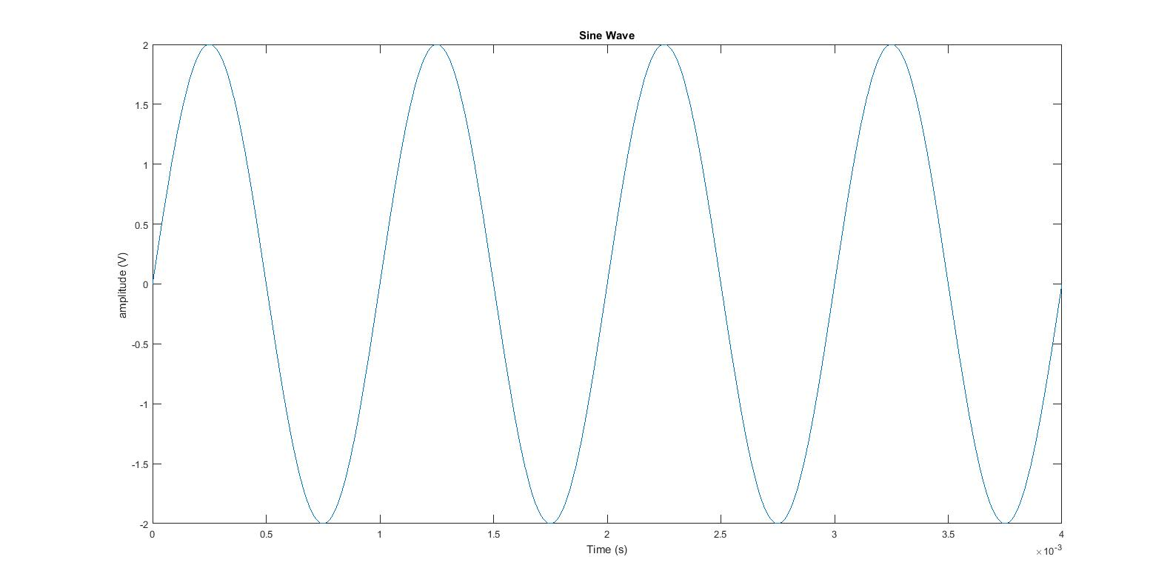
2V amplitude at 1kHz
  - Gee die tyddomein voorstelling van die volgende sein: /
Give the time domain representation of the following signal: [4]
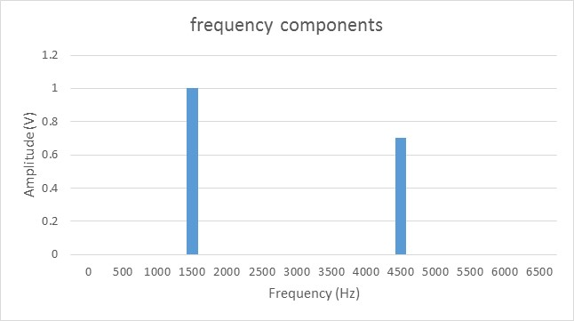
Figure 2-58 (a), blue line
  - Noem die 4 elemente van enige kommunikasiestelsel. /
List the 4 elements of any communications system. [2]

Transmitter, channel, noise, receiver

  - Definieer (i) basisband en (ii) breëband kommunikasie. /
Define (i) baseband and (ii) broadband communication. [2]

Baseband is found before a signal is modulated (thus unmodulated data or voice) before the signal is sent across a medium [2].

Wideband communication is usually after a signal has been modulated and usually refers to the signal that is transmitted across a medium [2].

  - ‘n Versterker versterk 40 mW na 200 W. Wat is die wins in dB? /
An amplifier amplifies 40 mW to 200 W. What is the gain in dB? [2]
Answer:
Ap = 200 / 40E-3 = 5E4 -> 10 log (Ap) = 37 dB [2]

  - ‘n Spanningsversterker het ‘n wins van 80 dB. As die insetsein 5 mV is, wat is die uitset in Volt? /
A voltage amplifier has a gain of 100 dB. If the input signal is 1 mV, what is the output in Volt? [2]
Answer: follow example 2-9:
Gain = 10^(80/20) = 10 000 -> Output = 5 mV *10 000 = 50V [2]
  - Verduidelik kortliks: (i) invoegverlies en (ii) vormfaktor /
Briefly explain (i) insertion loss and (ii) shape factor. [3]
i) Insertion loss is the attenuation that a filter gives in the passband [1]
ii) Shape factor is the ratio of stop-band [1] to pass-band bandwidths [1], e.g BW_{-60dB}/BW_{-6dB}.

  - ‘n Ontvanger het die volgende drywingswinselemente /
A receiver has the following power gain elements:

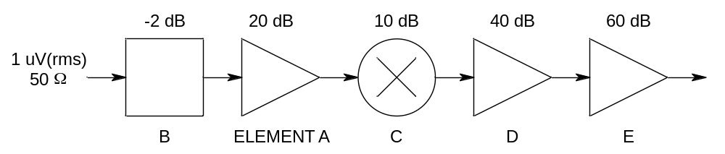

- Gee die totale wins van die ontvanger / Give the total gain of the receiver; [2]
- Bereken die uitsetdrywing in dBm / Compute the output power in dBm; [2]
- Wat sal die spanning wees oor ‘n 1 kΩ las / What will the voltage be across a 1 kΩ load? [2]

Totale wins = -2 + 20 + 10 + 40 + 60 = 128 dB [2]
Insetdrywing = 10 log (1E-6^2 / 50 * 1000) = -107 dBm [2]
Uitsetdrywing = -107 + 128 = 21 dBm -> Puit = 10^(21/10) = 125.9mW -> Vuit ≈ 11.22V [2]

Vraag 2 / Question 2 - [52]

  - Die maksimum piek-tot-piek sein van ‘n AM golf is 45V. Die piek-tot-piek waarde van die modulerende sein is 20V. Wat is die modulasie prsentasie?
The maximum peak-to-peak signal of an AM wave is 45V. The peak-to-peak value of the modulating signal is 20V. What is the modulation percentage? [3]
See figure 3-5
% = (Vmax-Vmin)/(Vmax + Vmin)
((45/2)-(45/2-20))/ ((45/2)+(45/2-20)) = (22.5-2.5)/(22.5+2.5) = 0.8 = 80%

  - Hoeveel drywing is in een syband van ‘n AM sender met ‘n 5kW draer sein wat teen 80% gemoduleer word?
How much power appears in one sideband of an AM signal of a 5kW carrier transmitter modulated by 80%? [3]
Use formula sheet: 5kW in carrier, Pt = (5kW(1+(0.8^2)/2)) = 6600
Sidebands equal, 6600-5000 = 1600 => 1600/2 = 800W

  - Wat is die bandwydte van ‘n AM sein waar ‘n 980kHz draer sein gemoduleer word deur ‘n modulasie sein met hoogste frekwensie component van 5kHz?
What is the bandwidth of an AM modulated wave where a 980kHz carrier is modulated by a with a highest frequency component of 5kHz? [2]
BW = 2(5kHz) – 10 kHz

  - Wat is die maksimum bandwydte van ‘n FM sein waarvan die frekwensiedeviasie 30kHz vir ‘n maksikmum modulasiesein komponent van 5kHz?
What is the maximum bandwidth of an FM signal with a deviation of 30kHz and a maximum modulating signal of 5kHz as determined by using Bessel functions? [4]

mf = fdev/fm = 30E3/5E3 = 6
Thus, from table, at modulation index of 6, 9 significant sidebands are visible, each equal to modulation signal bandwidth. Thus, 9*5kHz – 45kHz. But remember both sides of carrier, thus 2 * 45kHz = 90kHz

  - Teken die basiese elemente van ‘n tipiese lae-vlak FM versender (met indirekte FM) [4] en verduidelik elke element se funksie [4]. Jy hoef nie die antenne te noem of te beskryf nie. /
Draw the basic elements of a typical low-level FM transmitter (with indirect FM) [4] and explain each element’s function [4]. You don’t have to name and describe the antenna. [8]
Halwe punt vir elke feit...
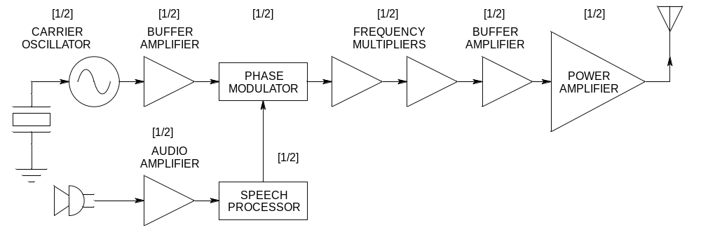

- Carrier oscillator – generates the carrier signal to be modulated [1/2]
- Buffer amplifier 1 – isolates the carrier oscillator (constant impedance) and provides gain [1/2]
- Phase modulator – performs indirect FM [1/2]
- Audio amplifier – amplifies intelligence signals [1/2]
- Speech processor – filters out high frequencies and processes speech for FM [1/2]
- Frequency multipliers – multiplies modulated carrier for RF transmission [1/2]
- Buffer amplifier 2 – provides adequate signal levels for power amplifier [1/2]
- Power amplifier – provides sufficient signal level for RF transmission [1/2

  - ‘n fasesluitlus sintetiseerder soos hiernaas aangedui het ‘n konstante voorverdeler waarde van M = 32, ‘n programmeerbare verdeler waarde van N = 16, en ‘n verwysingsfrekwensie van fref = 100 kHz /
The synthesizer indicated below has a constant prescaler value of M = 32, a programmable divider value of N = 16, and a reference frequency of fref = 100 kHz
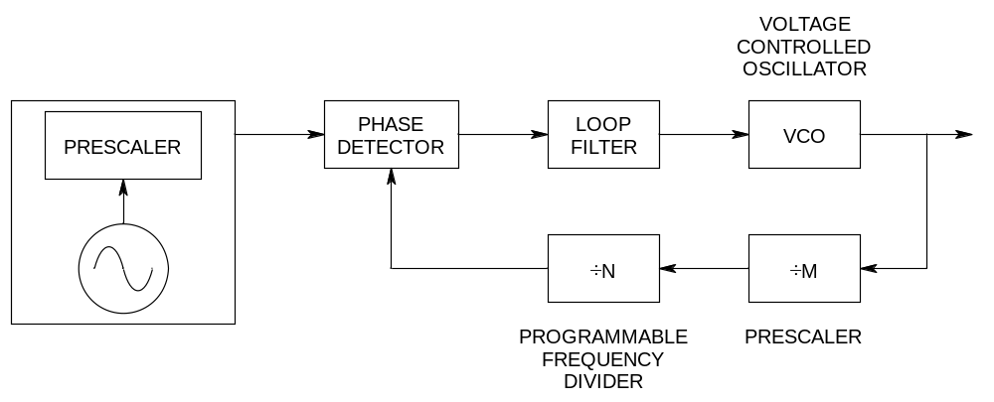

  - Bereken die uitsetfrekwensie /
Calculate the output frequency; [2]

f_{out} = M x N x f_{ref} = 51.2 MHz
  - Wat is die frekwensie-inkremente (resolusie)? /
What are the frequency increments (resolution)? [2]

Resolution = 100kHz x M = 3.2 MHz

  - Teken die blokdiagram van ‘n superheterodine ontvanger en benoem elke element duidelik. /
Draw the block diagram of a superheterodyne receiver and name each element clearly. [9]

Figuur 9-5 p295

  - ‘n Radio ontvanger het die volgende komponente met geassosieerde winste en verliese: /
A radio receiver has the following components with associated gains and losses:

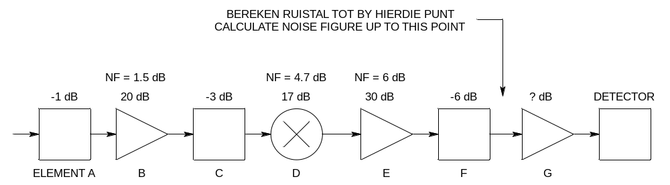
  - Bereken die saamgestelde ruistal van die ontvanger in dB. /
Calculate the combined noise figure of the receiver in dB. [6]
  - Wat moet die wins van element G wees om 1 Vrms vir die 1 kΩ detektor te lewer indien die drywing by die inset van element A -95 dBm is? /
What must the gain of element G be to provide a voltage of 1 Vrms to the 1 kΩ detector if the input power to element A is -95 dBm? [3]
  - Watter element lewer die grootste bydrae om ruis te beperk, en waarom? /
Which element contributes the most to limit noise, and why? [2]

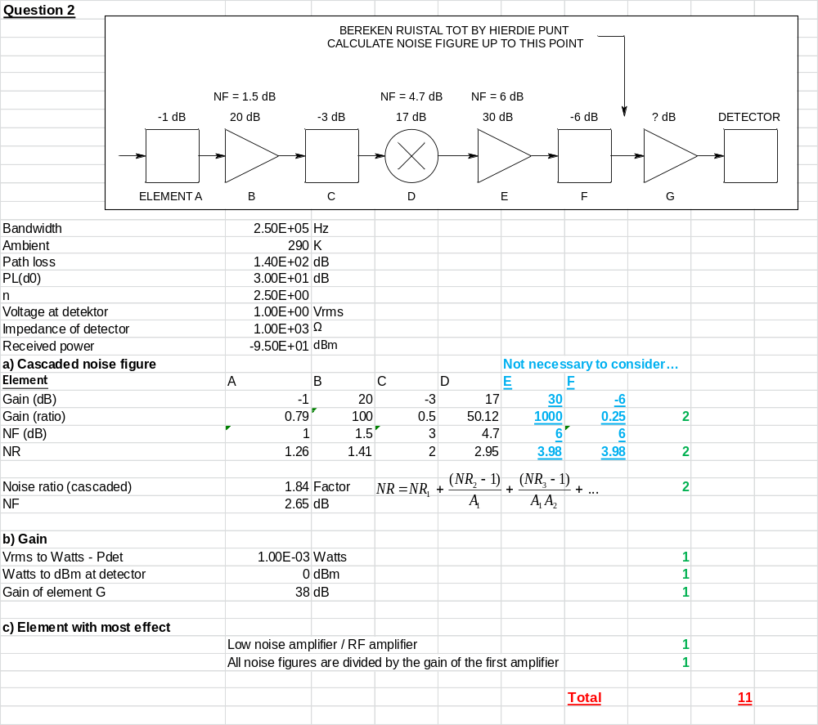

  - ‘n Ontvanger met ‘n 50 Ω insetimpedansie werk by ‘n temperatuur van 25 ºC. ‘n RF sein word ontvang met ‘n bandwydte van 50 kHz. Die seinvlak by die ontvanger is 1 μVRMS en die ontvanger het ‘n saamgestelde ruistal van 4 dB. / A receiver with a 50 Ω input impedance works at a temperature of 25 ºC. A signal is received with a bandwidth of 50 kHz. The signal level at the receiver is 1 μVRMS and the receiver has a noise figure of 4 dB.

  - Bereken die ruisdrywing. /
Calculate the noise power. [2]
  - Bereken die seindrywing. /
Calculate the signal power. [2]
  - Wat is die sein-tot-ruis verhouding voor die ontvanger? /
What is the signal-to-noise ratio before the receiver? [2]
  - Wat is die sein-tot-ruis verhouding by die uitset van die ontvanger? /
What is the signal-to-noise ratio at the output of the receiver? [2]

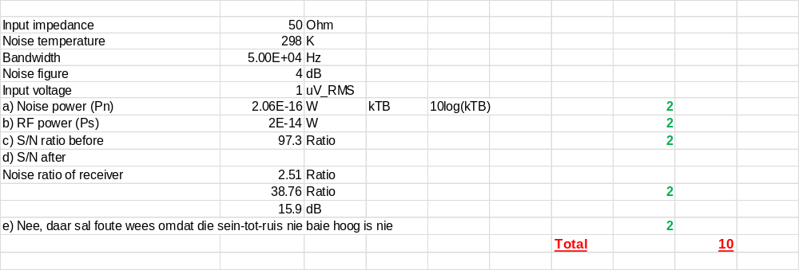

Formules EN TABELLE/ Formulas AND TABLES

